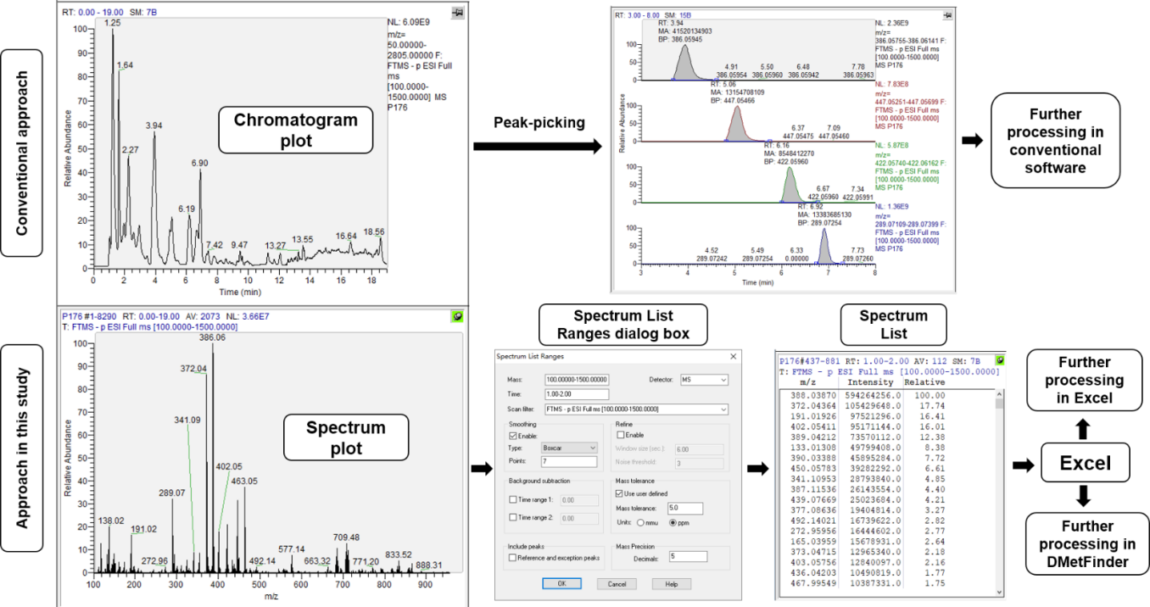
Supplementary Fig. S1. Metabolomic data-processing procedures for conventional processing software and the MS-based method developed in this study.

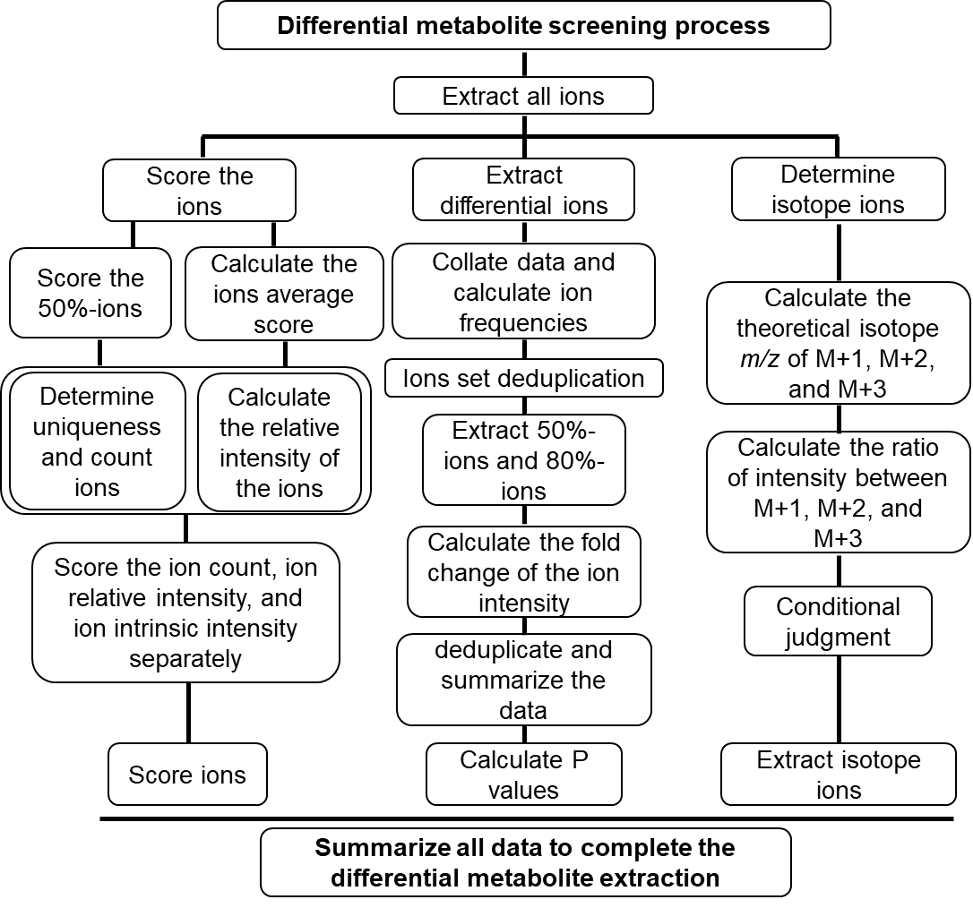
Supplementary Fig. S2. Technical roadmap of the screening method for differential metabolites in this study.

Supplementary Fig. S3. User interface of MSGeter, a software tool developed for mass spectrometry data extraction. (a) Interface for MS1 data extraction; (b) interface for MS/MS data extraction.

